**C PROGRAMMING ASSIGNMENT LABSHEET – 1**

**S.ABHISHEK**

**AM.EN.U4CSE19147**

**CSE - B**

**QUESTION 1**

TO FIND THE LARGEST AND SMALLEST ELEMENT IN THE ARRAY AND INTERCHANGE THEIR POSITION AND DISPLAY IT.

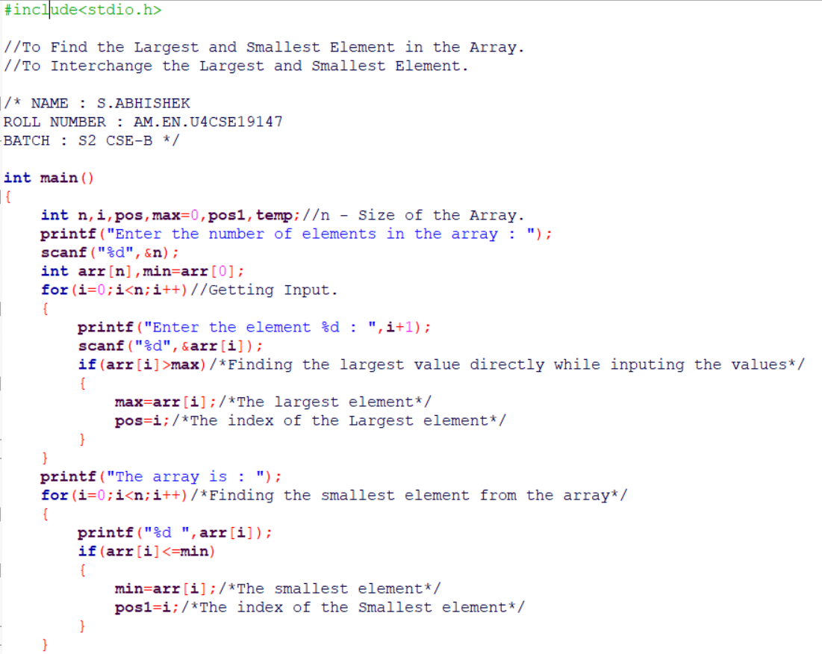

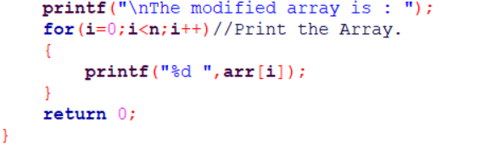

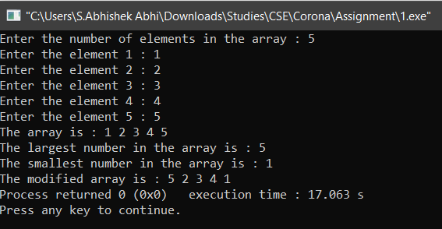

**QUESTION 2**

TO FIND THE SUM OF THE EVEN POSITIONED NUMBER.

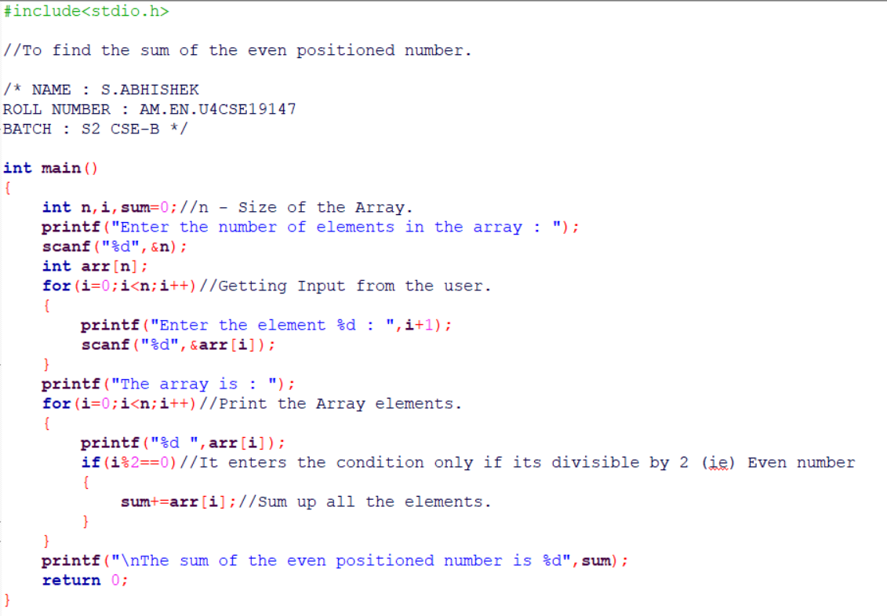

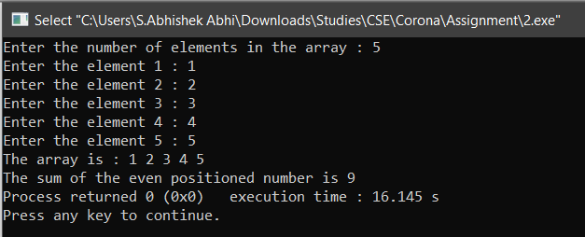

**QUESTION 3**

TO INPUT AN ARRAY AND FIND THE N’th SMALLEST NUMBER FROM THE ARRAY.

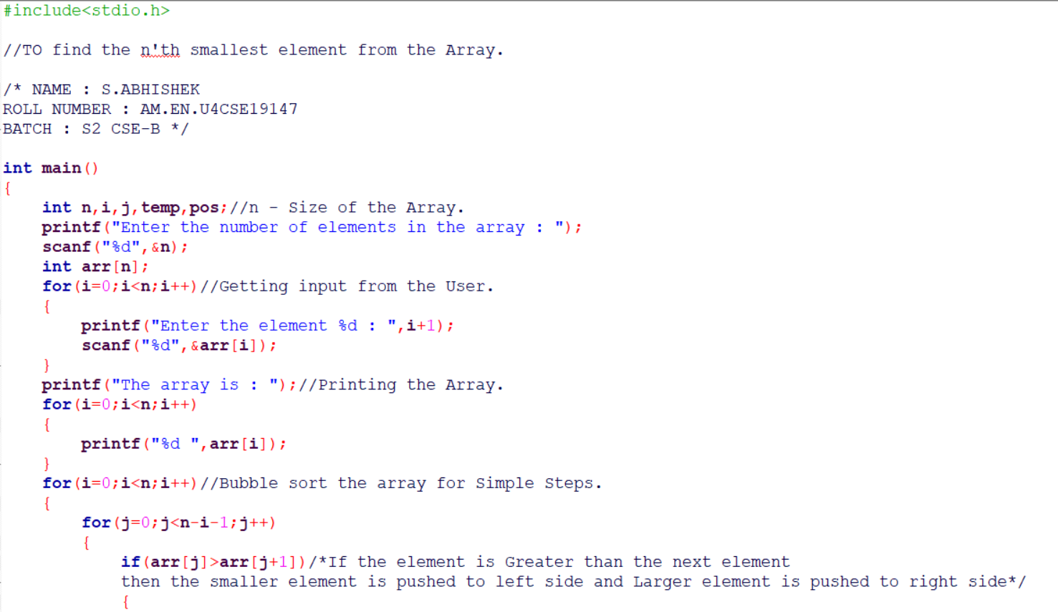

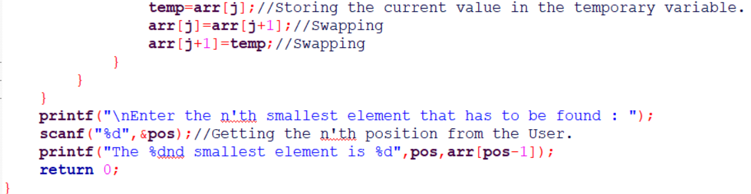

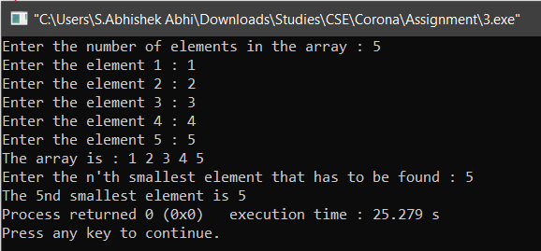

**QUESTION 4**

TO BUBBLE SORT THE ARRAY AND DISPLAY IT.

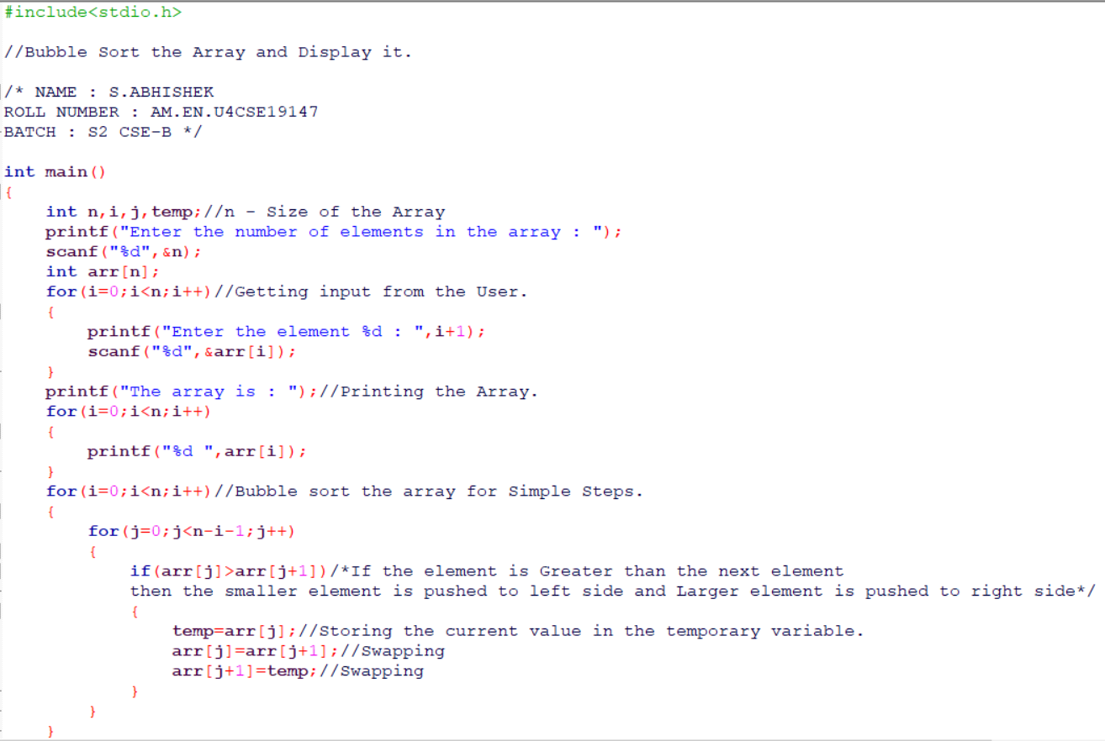

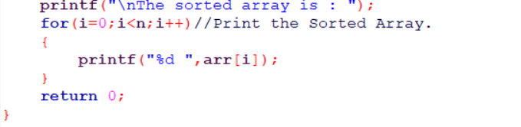

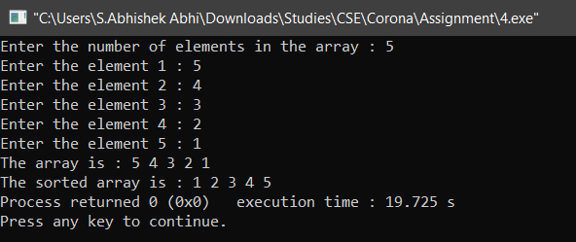

**QUESTION 5**

TO INPUT THE ARRAY AND INPUT THE ELEMENT FROM THE USER AND TO DISPLAY THE SMALLEST AND LARGEST ELEMENT CLOSER TO THE ELEMENT.

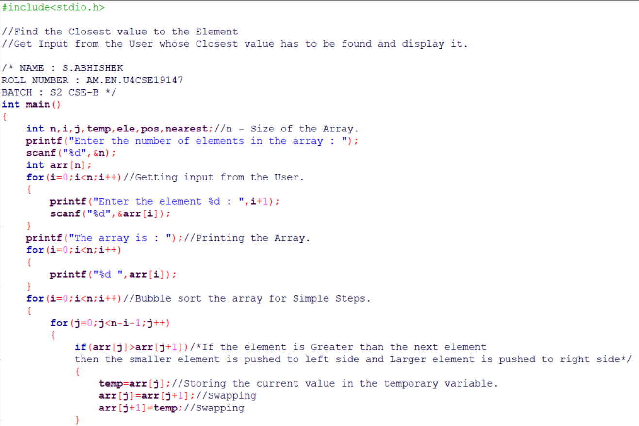

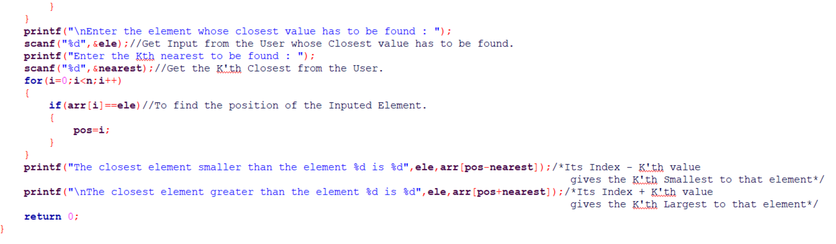

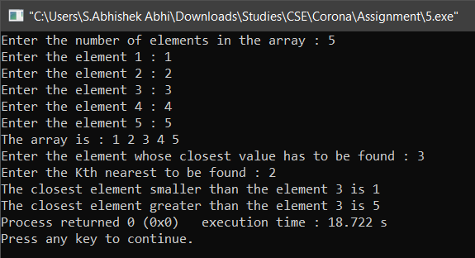

**QUESTION 6**

TO GET THE INPUT ARRAY FROM THE USER AND LEF TR RIGHT ROTATE THE ARRAY ACCORDING TO THE USER’S CHOICE.

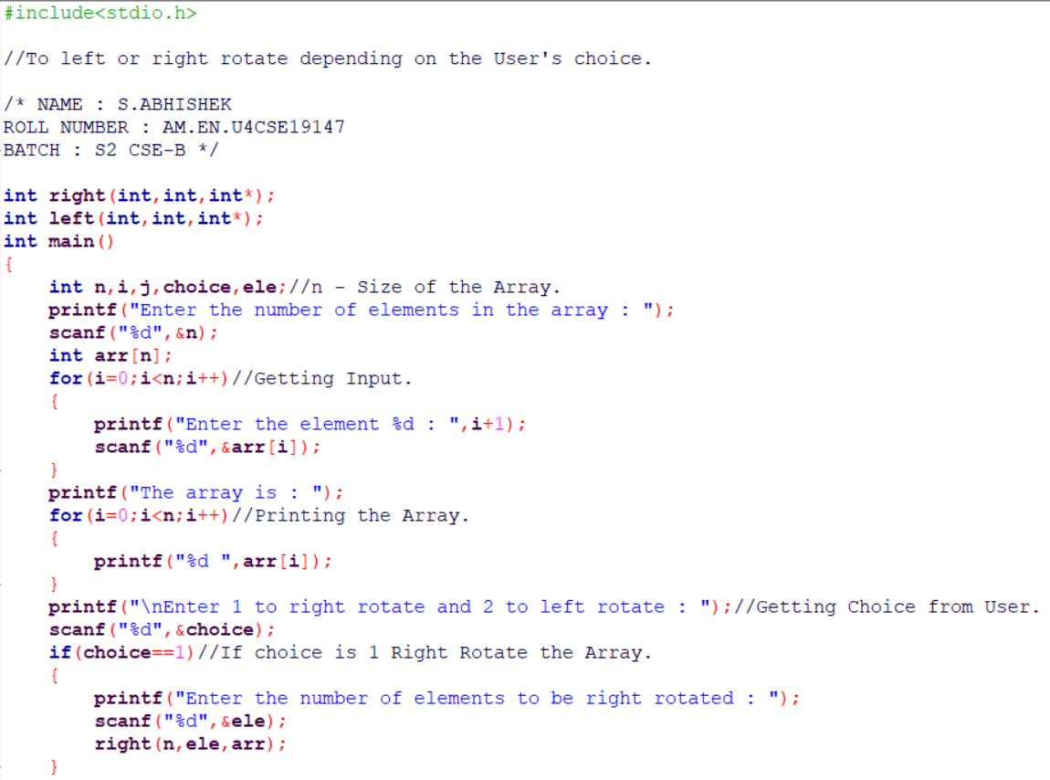

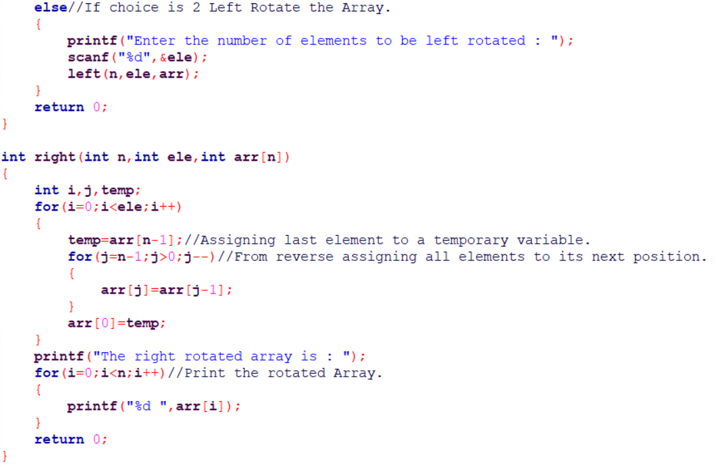

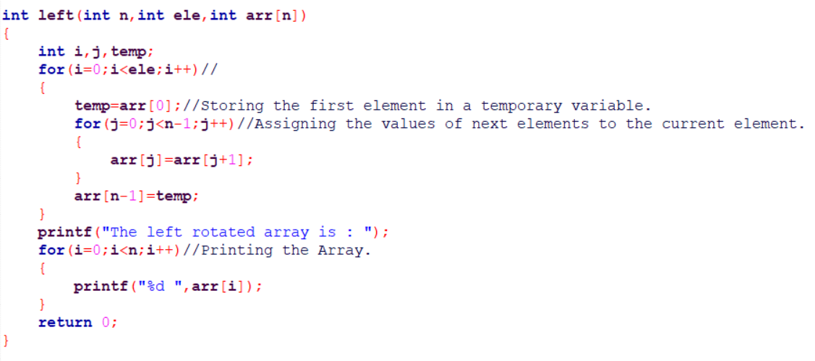

**RIGHT ROTATE:**

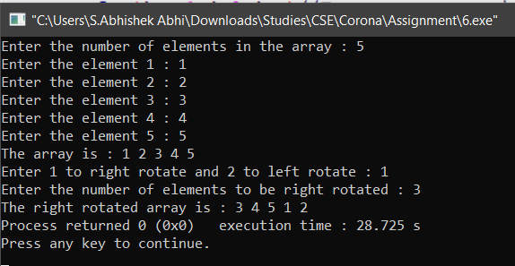

**LEFT ROTATE:**

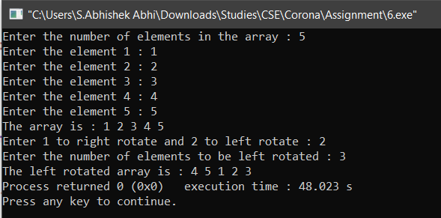

**QUESTION 7**

TO GET THE INPUT ARRAY FROM TE USER AND USER AND TO FIND THE NUMBER OF PAIRS WHOSE SUM IS ODD.

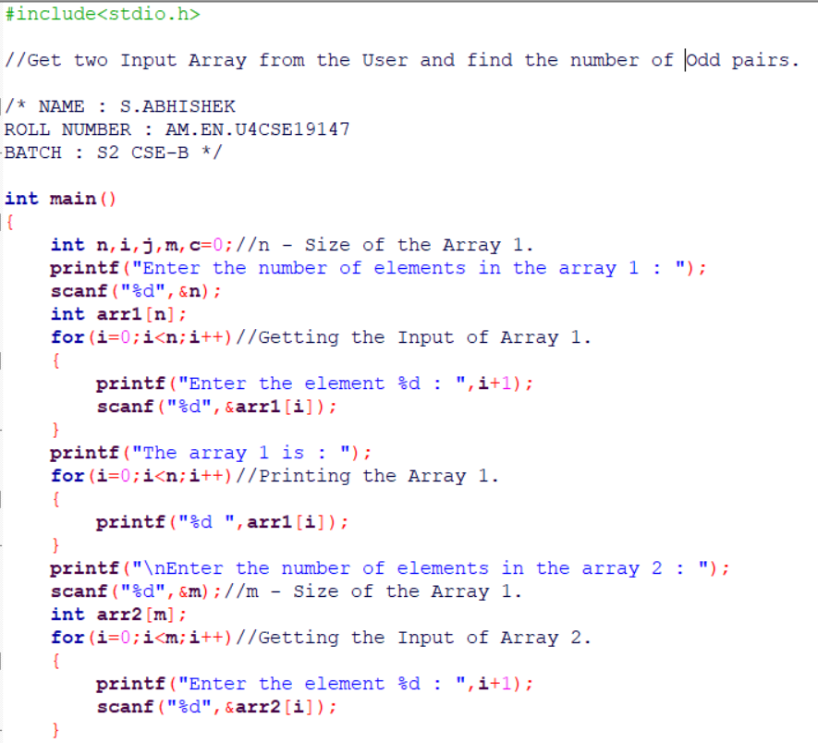

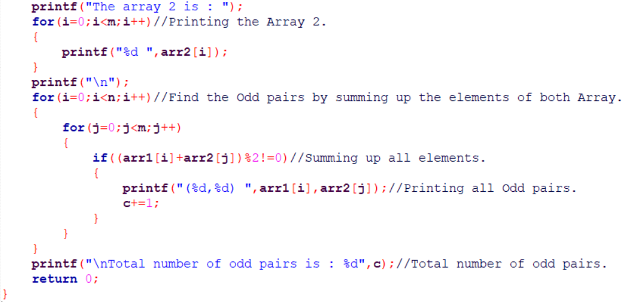

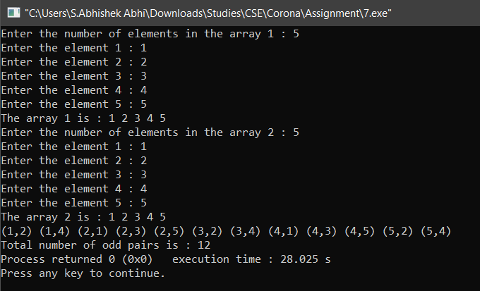

**QUESTION 8**

TO INPUT THE TWO SORTED ARRAY FROM THE USER AND TO FORM THE NEW SORTED ARRAY BY PICKING THE ELEMENTS ALTERNATIVELY FROM BOTH THE ARRAYS. THE FIRST ELEMENT IS FROM THE ARRAY 1.

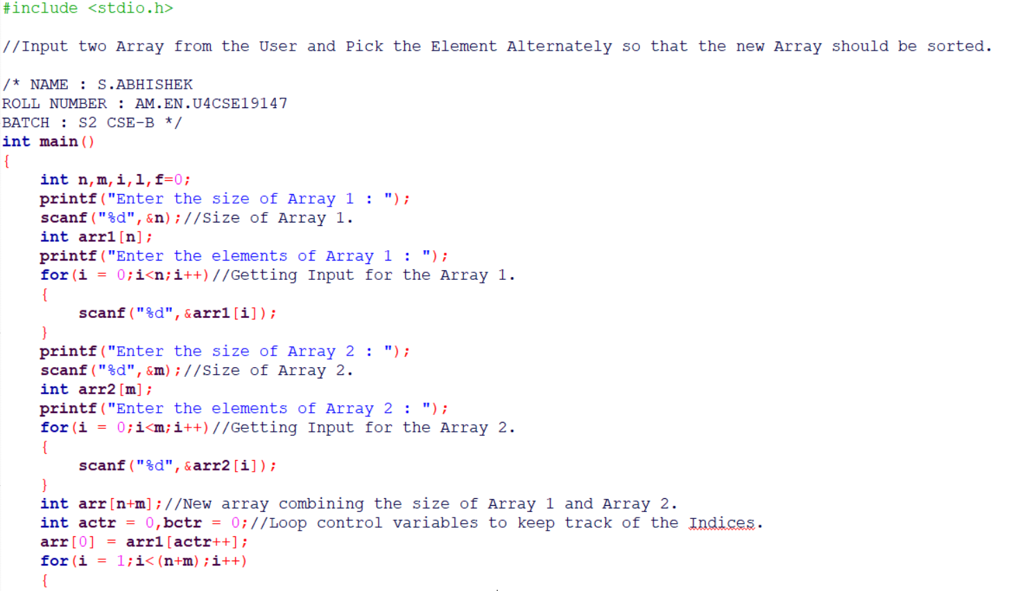

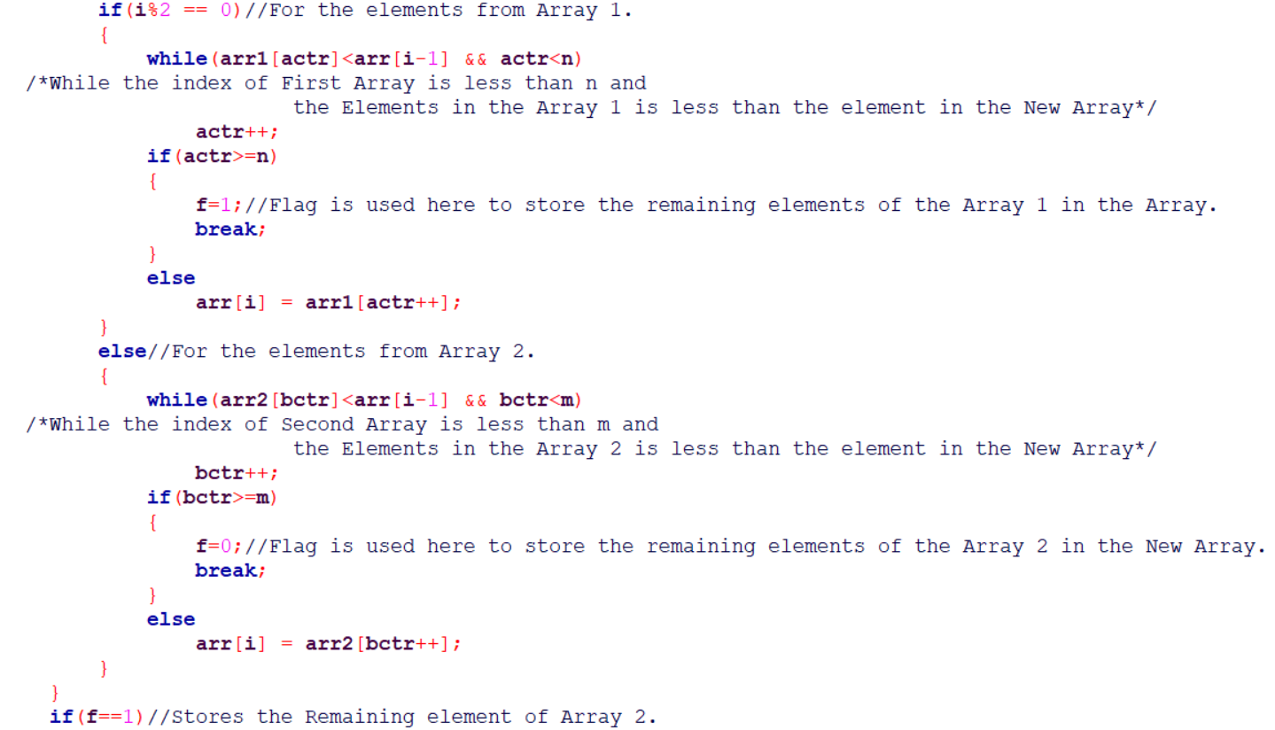

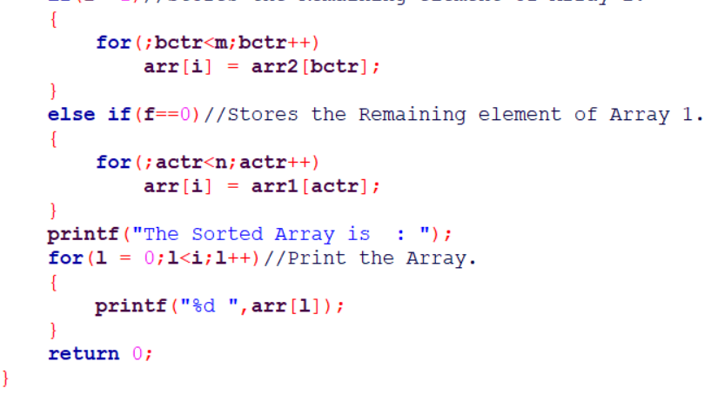

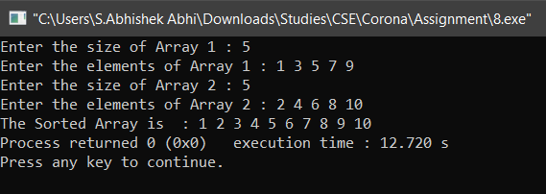

**QUESTION 9**

TO PERFORM THE FOLLOWING OPERATIONS IN THE CAR QUEUE BASED ON THE USER’S CHOICE :

1. PUSH()
2. POP()
3. TOP()
4. NEXT()

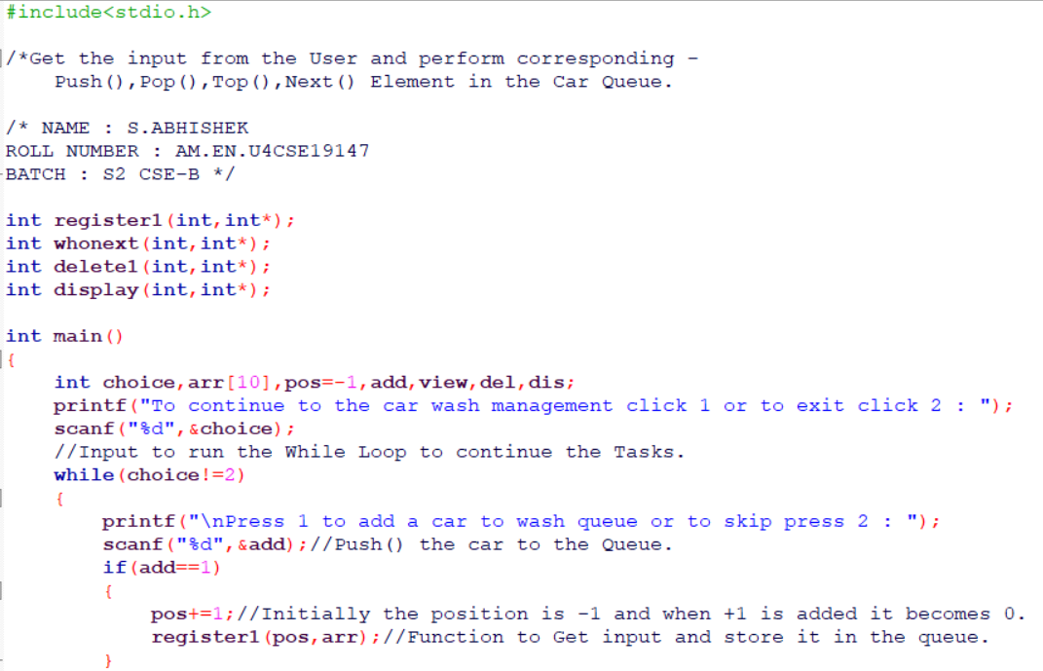

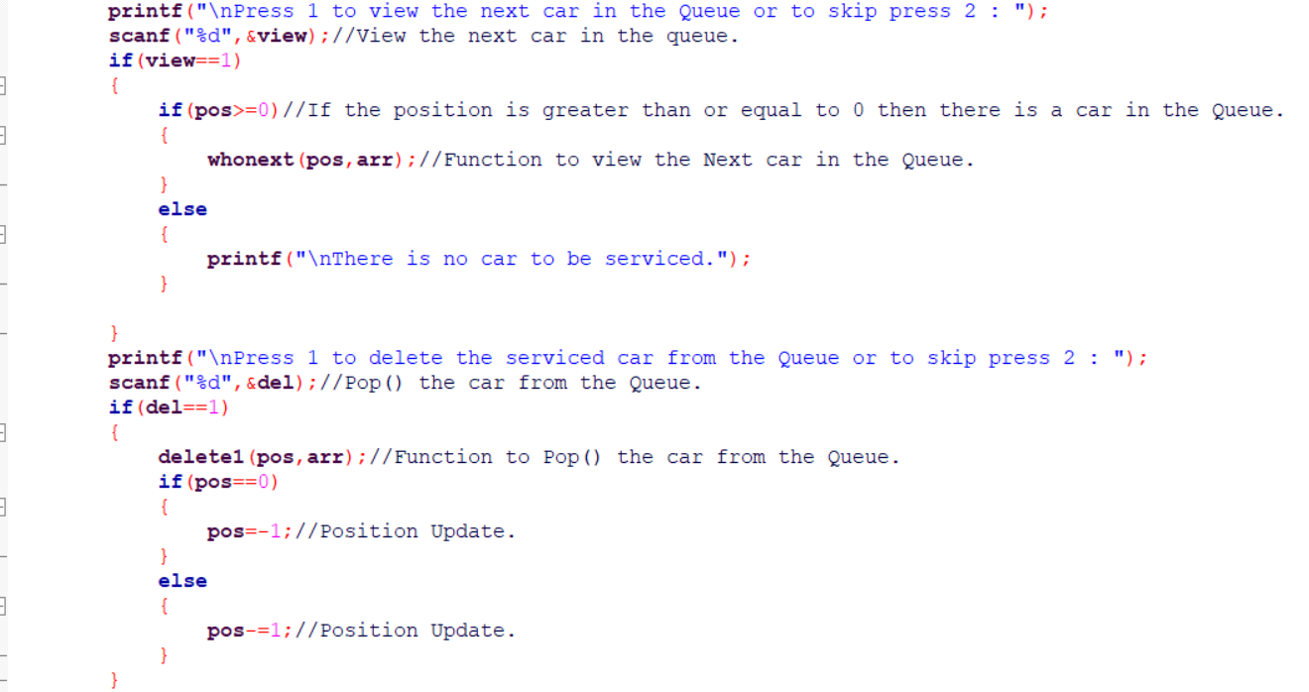

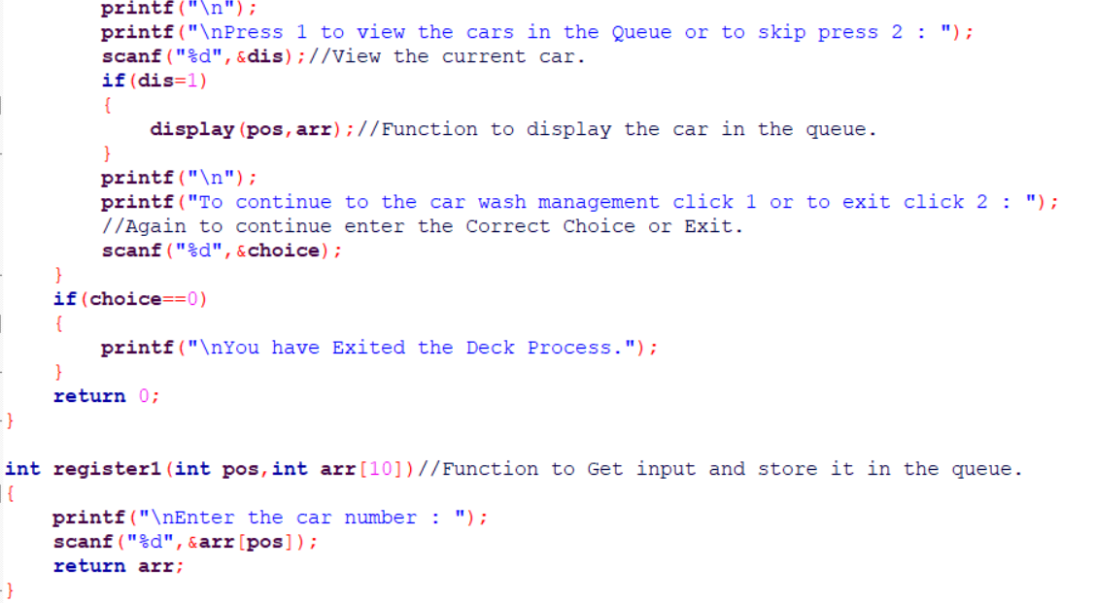

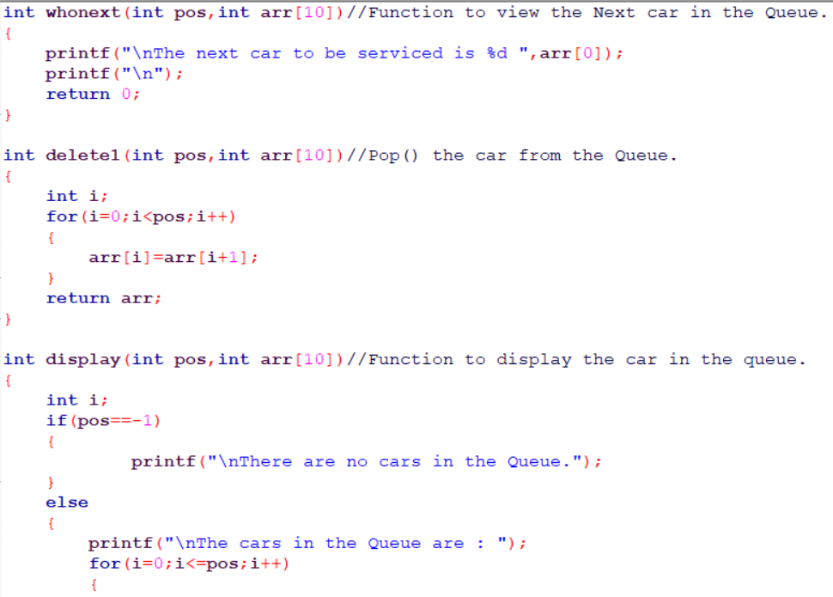

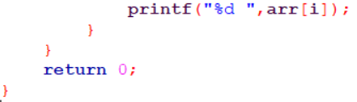

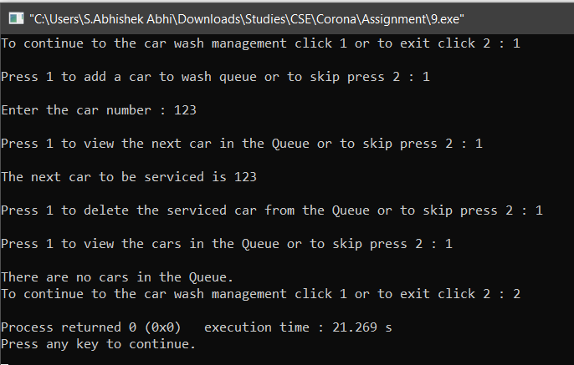

**QUESTION 10**

TO PERFORM THE FOLLOWING OPERATIONS IN THE CARD DECK BASED ON THE USER’S CHOICE :

1. PUSH()
2. POP()
3. WHONEXT()
4. TOP()

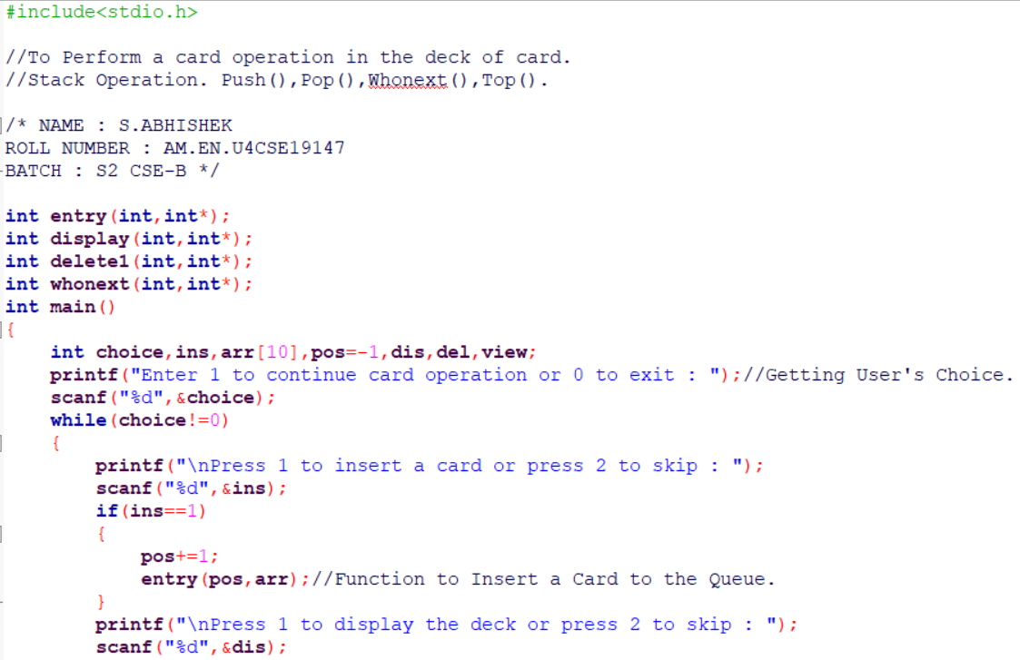

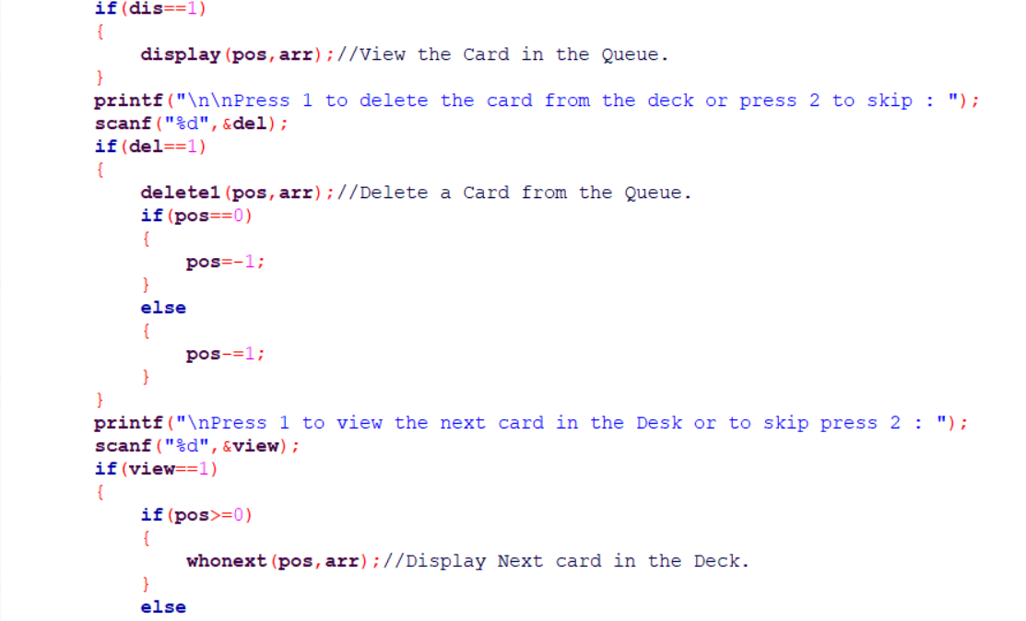

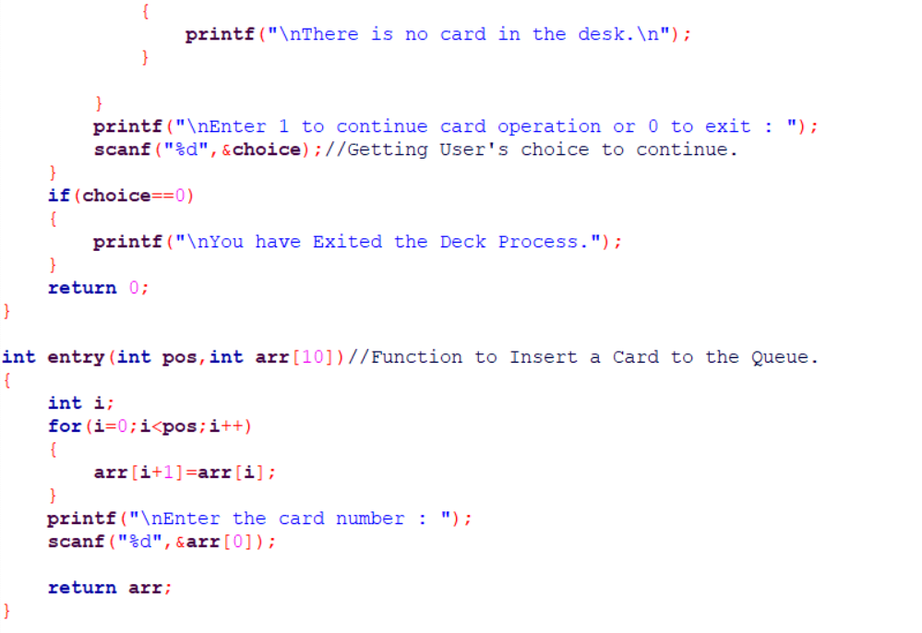

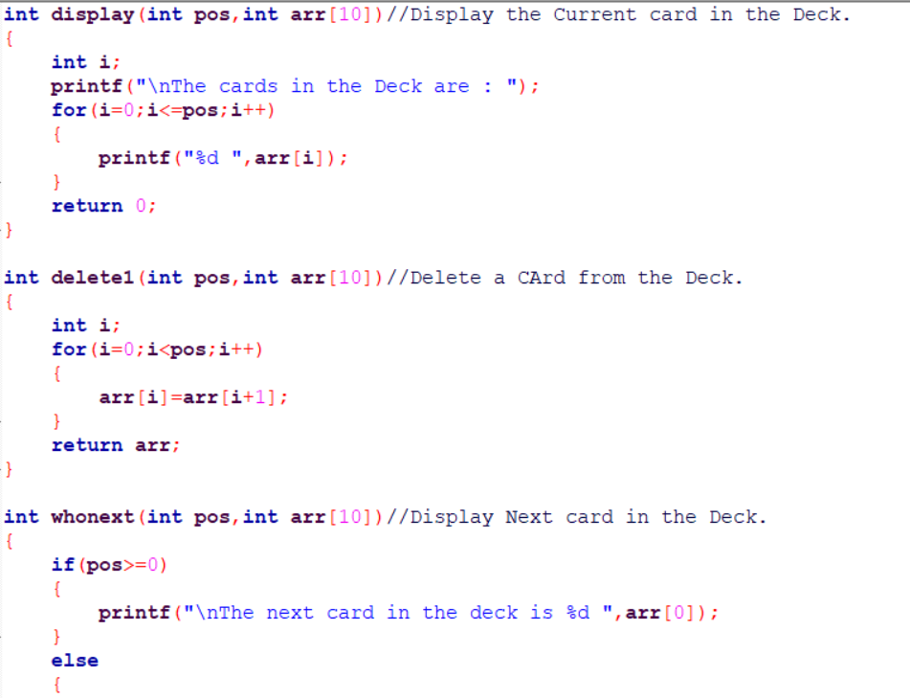

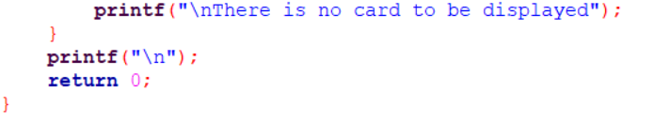

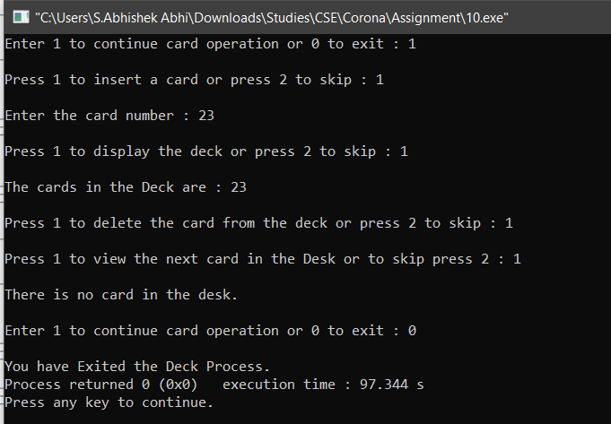

**!... THANKYOU …!**